Date: XX XX XX
Turing House School
L.B. Richmond upon Thames

Draft Agreement in relation to arrangements for community use of sports facilities at Turing House School
In connection with Planning Permission XXXX

Contents
No Heading Page
Clauses
1. Recitals 2
2. Definitions and Interpretation 2
3. Aims 3
4. Arrangements for Community Use 4
5. Targets for Community Use 4
6. Marketing and Promotion 4
7. Management 4
8. Financial Matters 6
9. Monitoring and Review 6
10. Duration of Agreement 7
11. Authority 7
12. No Variations 7
13. No Agency 8
14. Severability 8
15. Waiver 8
16. Non-Assignability 8
17. Governing Law and Jurisdiction 8
Schedule 1 9
Schedule 2 12
Schedule 3 16

DATE XX XX XX
(1) TURING HOUSE SCHOOL of Hospital Bridge Road, Twickenham. TW2 6LH (“the School”)
(2) L.B. RICHMOND UPN THAMES LOCAL AUTHORITY of Civic Centre, 44 York Street, Twickenham TW1 3BZ (“the Council”)

Recitals
  - Planning Permission was granted by the Council for the Development subject to conditions. One condition requires that an agreement shall be submitted to the local planning authority for approval to demonstrate how community access to the Sports Facilities within the Development and/or the wider school site will be managed.
  - The parties wish to enter into this Agreement in order to make the indoor and outdoor Sports Facilities at the Development, available (when their use is not required by the School) for use by the local community in compliance with the terms of this Agreement.
  - It is anticipated that the School will hold the School Premises on a 125-year Lease from the S of S for Housing, Communities and Local Government. Assuming the Lease is agreed then the School will be responsible for their use.
  - The Council has responsibility for the provision of sports facilities in the L.B Richmond area for use by and for the benefit of the community and is desirous of entering into this Agreement in furtherance of that responsibility and as the local planning authority in respect of the Development.

Definitions and Interpretation
In this Agreement the following words or phrases have the corresponding meanings ascribed to them unless the context otherwise requires:
Block Booking means booking of part or all the Sports
Facilities for a specific time and day of the week for at least one Academic Term payable in advance.
Community Use means use of the Sports Facilities by the local community including organised sports clubs and other organisations.
Development means erection of 5 FE secondary school and Sixth Form including playing pitches, 3 court MUGA and Sports Block for which Planning Permission has been granted
Sports Facilities means the sports facilities identified in Schedule 1 to this Agreement forming part of the School Premises
Management Committee means the management committee as defined in clause 7.1 of this Agreement
Parties means the parties to this Agreement
Planning Permission means planning permission (reference XXXXXXXX granted by the Council on XXXXXXX)
Review Committee means representatives of each of the Parties to this Agreement or their nominees
School Premises means the land and buildings comprising Turing House School

Aims
The Parties agree to pursue the following aims:
- Providing opportunities for the local community and sports organisations to participate in sport and physical activity for health improvement and development of their skills, particularly amongst low participant groups;
- Operating in line with the national agenda for sport taking into account nationally adopted strategies;
- Generating positive attitudes in sport and physical activity by young people and reducing the dropout rate in sports participation with age;
- Increasing the number of people of all ages and abilities participating in sport and physical activity including people with disabilities;
- Using the facilities to encourage the range, quality and number of school sports club links and to stimulate competition that is inclusive of young people and adults;
- To provide affordable access to the facilities and to be self-financing in terms of community use;
- To assist in establishing and integrating the School in the local community by offering Sports Facilities for hire.

Arrangements for Community Use
The School agrees to make the Sports Facilities available for Community Use in accordance with the provisions of Schedule 2 to this Agreement.

Targets for Community Use
The School shall use reasonable endeavours to achieve community use targets where appropriate in line with appropriate sports development strategies, including contributing to local participation targets for sporting and physical activity. The School shall work with L.B. Richmond upon Thames Sports Development Team to provide a range of opportunities and pathways for the community. These may include existing initiatives and will also include new and local activities.

Marketing and Promotion
The School will be responsible for marketing and promoting the Sports Facilities in accordance with the agreed aims and targets. A marketing strategy will be prepared and implemented and reviewed on an annual basis.

Management
  - A Management Committee will be established within X months of the date of this Agreement to develop Community Use of the Sports Facilities in accordance with the terms of reference and constitution of Schedule 3 to this Agreement.
  - Membership shall include representative(s) (or their nominee) from each of the following: -
- The School. This will be the Head teacher as well as the Chair of the Schools Finance and Premises Cttee (or equivalent Cttee).
- The Council
- A representative from the community for the first X months from XX 2021 – 31 August 2021. This place will be taken by a representative from user groups of the Sports Facilities Hall from 1 Sept 2021.
- Russell Education Trust
  - Under these terms of reference, the Management Committee will, in accordance with this Agreement, seek to establish a practical policy framework for the management and operation of the Sports Facilities during agreed periods of Community Use. This framework should seek to enable:
- a policy of affordable pricing to assist in the achievement of the aims of this Agreement. The policy will ensure that prices shall not be materially different than similar local authority run facilities and local Schools in the area and offer a discounted rate for Block Bookings;
- the promotion and forward planning of development activities, at times which best suit the target groups;
- equal opportunities of access;
- an easy and accessible booking arrangement for Community Use, this system to be reviewed on an annual basis;
- an appropriate marketing strategy for the marketing of the Sports Facilities for Community Use.
7.4 The School will be responsible for the Sports Facilities and shall: -
- resource, control and routinely ensure the maintenance of the Sports Facilities in a manner that will allow achievement of the agreed aims, and
- make the Sports Facilities available on the occasions and times specified in Schedule 2;
- ensure provision of heat, light and water and such other amenities as required for the Sports Facilities and their intended use;
- ensure that the Sports Facilities comply with all legislation and guidance in force at the time of this Agreement relating to access for disabled users;
- cover the cost of gas, fuel, oil, electricity, water, rates and taxes that may be attributable to the use of the Sports Facilities.

Financial Matters
  - The School endeavours to ensure that the costs of operating Community Use at the Sports Facilities will be fully covered by income from such use and any surplus will be utilised to:
    - contribute to a contingency or sinking fund for major maintenance, repairs and ultimately renewal of fixed life elements of the Sports Facilities.
    - repair or replace the stock of sports equipment such as basketball posts, netball posts, 5 aside goals for use in connection with the Sports Facilities where required

Monitoring and Review
  - At least 1 month prior to the date on which the Review Committee produces its annual report the School shall make available to the Review Committee details of all usage, bookings, maintenance and financial matters relating to the Community Use of the Sports Facilities to assist with the development and improvement of community access.
  - The Review Committee shall undertake an assessment of the adequacy of the implementation of this Agreement in relation to:
  - hours of use of the Sports Facilities;
  - pricing policy;
  - compliance with targets and aims of this Agreement;
  - marketing;
  - financial performance of the Sports Facilities during the previous year; and
  - maintenance.
  - The Review Committee shall prepare a report based on the above assessment and prepare recommendations as to how Community Use of the Sports Facilities can be further developed and improved.
  - The School shall implement all reasonable recommendations of the Review Committee as soon as reasonably practicable.
  - In the event any significant changes are required to this Agreement as a consequence of each or any annual review prior written approval of each of the Parties to this Agreement shall be required.
  - The School shall not materially reduce the level of community access to the Sports Facilities required by the Planning Permission without the prior written approval of the local planning authority following consultation with Sport England. It is however recognised that the School will need to use the Sports Hall for formal public exams and the internal mock public exams as well as one off annual event’s such as “careers fayre” so it will not be available for hire during these periods. The Council will be advised at the start of each Academic year as to the expected dates and durations of such public exams and other events. Actual Dates will then be confirmed when known. Wherever possible Community Hirers will be provided with at least 4 weeks’ notice.

Duration of Agreement
This Agreement shall operate for so long as the School Facilities are provided in accordance with the Planning Permission. In the event the School should cease the Parties agree to make every effort to secure the continued operation of the Sports Facilities for Community Use.

Authority
The School warrants that it has the full right and authority to enter into this Agreement.

No Variations
This Agreement may only be varied in writing by a document executed by all the Parties hereto.

No Agency
Nothing in this Agreement shall be construed as creating a partnership, a joint venture, a contract of employment or a relationship of principal and agent between the parties hereto.

Severability
If any term condition or provision contained in this Agreement shall be held to be invalid unlawful or unenforceable to any extent such term condition or provision shall (save where it goes to the root of this Agreement) not affect the validity legality or enforceability of the remaining parts of this Agreement.

Waiver
No term or provision of this Agreement shall be considered as waived by any party to this Agreement unless a waiver is given in writing by that party.

Non-Assignability
This Agreement is personal to the parties and none of them shall assign sub-contract or otherwise deal with their rights or obligations without the prior written consent of the others.

Governing Law and Jurisdiction
This Agreement shall be governed by the laws of England and Wales and the parties submit to the exclusive jurisdiction of the courts of England and Wales.

      - The outdoor sports areas and facilities to be made available for Community Use shall comprise the playing pitches and Multi Use Games Area (as shown on the plan below). InIn the summer if a cricket wicket is viable given condition of grass at that time then the Management Cttee will set a price for this having regard to other local facilities.

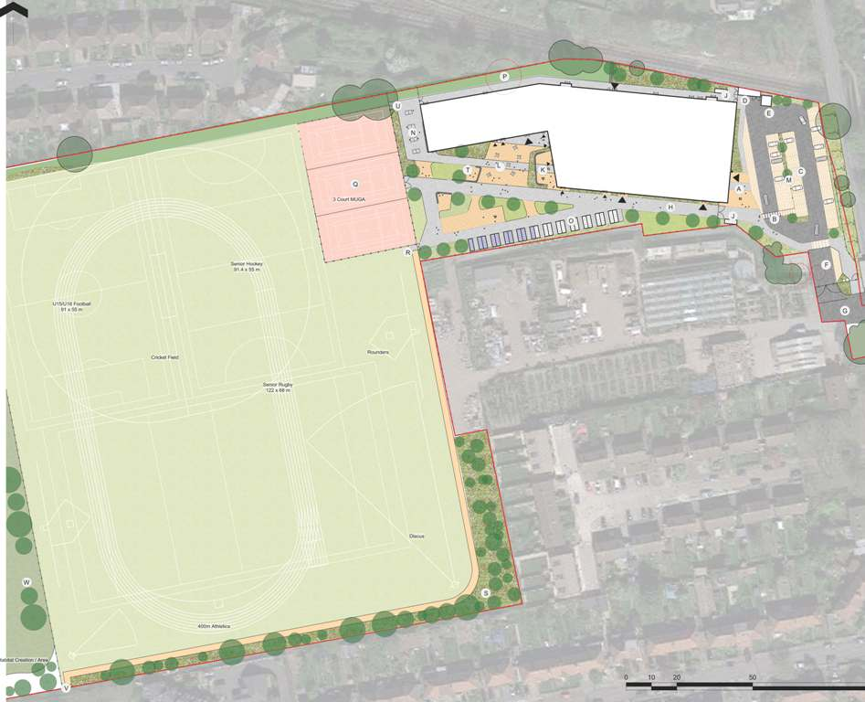

      - The indoor sports hall and activity studio together with ancillary facilities such as toilets and changing rooms to be made available for Community Use are as shown on the plans below: -
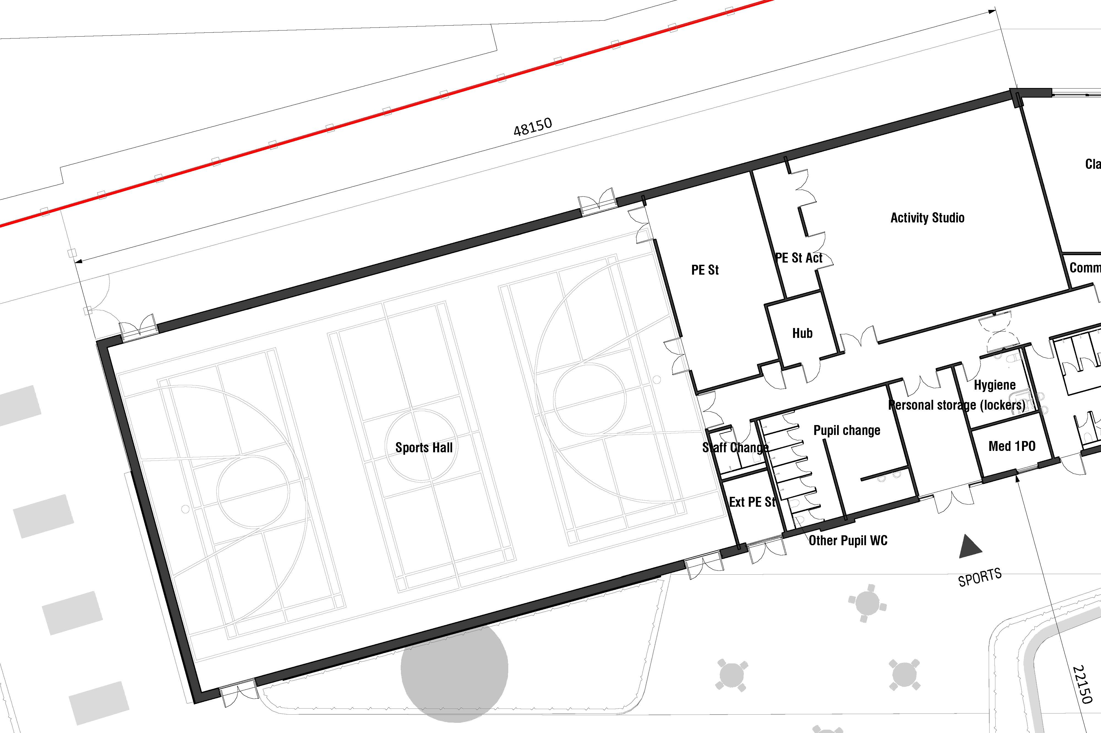

Arrangements for Community Use
      - Users
        - The Sports Facilities shall be made available for Community Use.
      - Hours of Access
TERM-TIME
Community Use Mon - Fri: 17.30 to 20.30
Sat: 09.00 – 13.00
SCHOOL HOLIDAYS
Community Use Mon -Fri: 09.00 -17.00
Sat: 09.00 -13.00
NB Subject to the School providing appropriate justification to the management committee, the School may restrict the use of grassed sports areas to protect them to fit in with the school requirements.
      - Pricing
        - A policy of affordable pricing shall apply to maximise Community Use and in accordance with the aims of this Agreement. Prices shall be not be materially different to those for similar local authority run facilities and local School facilities in the vicinity of Twickenham.
Turing House School
3.2 Prices will be benchmarked against a similar range of local facilities noted in para 3.4 and 3.5 prior to opening.
3.3. Prices for subsequent years when the Sports facilities are available for hire will be reviewed by the Management Committee and will be set for each academic year i.e. 1 Sept to 31.Aug.

Facility | Mon – Fri / hour. Excl. Vat  £ p | Saturday / hour Excl. Vat  £ p | Comment
Outdoor Sports facilities (Pitch) |  |  | Football or Rugby Pitch
Multi Use Games Area |  |  | This is for the whole MUGA. Where a Community Group wishes to book e.g. one netball court then the rate will be 33.3% of the whole MUGA rate.
Indoor Sports Hall |  |  | This is for the whole Sports Hall. Where a Community Group wishes to book e.g. one badminton court then the rate will be 33.3% of the whole Sports hall rate.
Indoor Activity Studio
Note a 10% discount on the applicable hourly rate is offered for Block Bookings of all or part Turing House School Sports Facilities.
London Borough of Richmond operated Facilities (rates charged will be inserted for year when Agreement is to be completed.)
3.4
Facility | Hampton Sports and Fitness Centre  Charge per hour £ p | Teddington Sports Centre (Teddington School)  Charge per hour £ p | Whitton Sports and Fitness Centre (Twickenham School)  Charge per Hour £ p | Comment
Outdoor Sports facilities (Pitch) | N/A | N/A | N/A | Each of these facilities have 3G pitches not grassed pitches
Multi Use Games Area
5 -a side | Y | N | Y
Netball | Y | Y | y | Hampton Court is Floodlit
Indoor Sports Hall
Badminton | Y | Y | Y
Basketball | Y | Y | Y
Cricket nets | Y | Y | Y
5 a side | N | N | Y
Netball | Y | Y | Y
Table Tennis | N | Y | Y | Teddington rate is for 45 mins
Volley ball | Y | Y | Y
Whole Sports hall | Y | Y | Y
Indoor Activity Studio | N | Y | N
Other Local School’s Rates will be shown for the year the Agreement is completed.
3.5 The rates charged by local schools for their Sports Facilities are shown in the table below: -

Facility | The Heathland School  L.B. Hounslow  Charge / Hour  Excl. VAT  £ P | Reach Academy Feltham  L.B. Hounslow  Charge / hour  Excl. Vat  £ p | Richmond College
Outdoor Sports facilities (Pitch) | N/A | 4G on Sports hall roof | Y
Outdoor netball court | Y | Y (Floodlit)
Indoor Sports Hall | Y | Y (4 Court) | Y
Badminton Court | Y | Y
Basket ball | N | Y
Football | N | Y
Netball Court | Y | Y
Table tennis | N | Y
Indoor Activity Studio | Side Hall | N | Y (Fitness suite)
      - Booking arrangements
        - An easy and accessible advance booking arrangement for Community and Sports Organisations Use including block booking by these organisations shall be established for hire of the Sports Facilities using a standard booking form.
        - The agreed booking arrangements shall operate as follows: -
It is intended when the School commences hiring of facilities that contact is made with the School’s Admin team on XXXXXX or email lettings@turinghouseschool.org.uk
      - Parking Arrangements
        - The School encourages users of the Sports Facilities to use public transport although there is car parking and cycle storage on site.

Management Committee

Terms of Reference and Constitution
      - Purpose
            - To monitor progress against agreed aims and targets: programming, usage and financial and to provide regular reports for the stakeholders of the school on those topics.
            - To decide on policy issues e.g. pricing, the framework of sports programmes and staffing.
            - To ensure effective partnership working between the organisations involved in school community use.
      - Officers
The Chair shall have the following roles;
- Role of Chair:
  - To direct and control the meetings of the committee.
  - To cast a further vote if necessary, to resolve any tied decision(s).
  - To represent the committee at other meetings and functions as necessary.
A Secretary will be elected by the full committee at the first meeting of each academic year (Sept to August) and will serve for one full year.
- Role of Secretary:
  - To compile and maintain minutes of all meetings.
  - To compile and issue agendas for meetings in timely fashion.
  - To take care of all communications to and from the committee.
      - Operation
            - The full committee will convene at least 2 per annum. Additional meetings will be held as considered necessary by a simple majority of members.
            - The School will resolve day to day issues. Whilst the School has full authority for any decisions it must adhere to the policy framework established by the full committee.
            - Day to day operation will be the responsibility of the School.
            - Sub-groups/committees may be formed by the Management Committee if considered necessary or desirable.
      - Reporting
            - Minutes of committee meetings will be maintained.
            - A formal annual report, as set out in paragraph 9.2 and 9.3 of this Agreement, will be issued to cover policy, financial and sports development matters.
            - Other specific reports requested by other committee members when possible.
IN WITNESS whereof the hands of the parties or their duly authorised representatives the day and year first above written.

[Amend as appropriate]
Signed by …………………………………
Duly authorised by the School

Signed by …………………………………
Duly authorised by the Council

