

### PLANNING REPORT

Printed for officer by

Gaetano Perillo on 19 April 2021

###### ENVIRONMENT DIRECTORATE

***USTOMER SERVICES***

**Application reference: 21/0597/CON**

|  |  |  |  |
| --- | --- | --- | --- |
| **Date application received** | **Date made valid** | **Target report date** | **8 Week date** |
| 19.02.2021 | 19.02.2021 | 16.04.2021 | 16.04.2021 |

**Site:**

|  |
| --- |
| 91 Highdown, Worcester Park , KT4 7JD, |
| **Proposal:** |
| Erection of single storey rear extension.  Status: Pending Decision (If status = HOLD please check that all is OK before you proceed any further with this application) |
|  |

|  |  |  |
| --- | --- | --- |
| **APPLICANT NAME**  Royal Borough Of Kingston  Royal Borough Of Kingston  Guildhall 2  Kingston-Upon-Thames  Surrey  KT1 1EU |  | **AGENT NAME** |

**DC Site Notice:**  printed on and posted on and due to expire on

**Consultations:**

***Internal/External:***

|  |  |
| --- | --- |
| **Consultee** | **Expiry Date** |
|  |  |
|  |  |

**Neighbours:**

-

**History: Development Management, Appeals, Building Control, Enforcements:**

No History Dummy UPRN

No History Dummy UPRN

No History Dummy UPRN

No History Dummy UPRN

**21/0597/CON**

**91 Highdown, Worcester Park, KT4 7JD**

Site and proposal

This submission comprises a Consultation application from Royal Borough of Kingston in respect of a single storey rear extension to a semi-detached property located on the southern side of Highdown, backing onto gardens of properties in Cleveland Gardens.

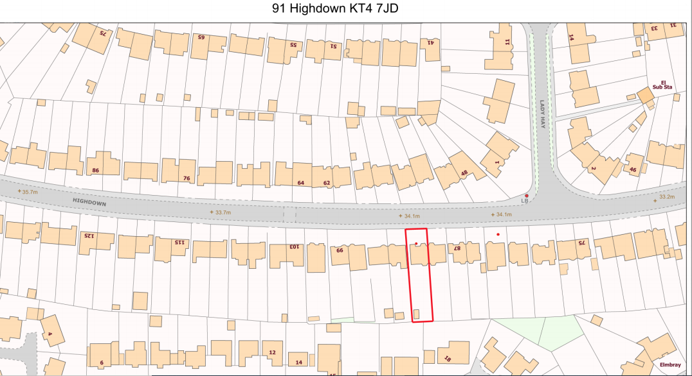

The property has a single storey side extension and the proposal is for a 4m deep single storey rear extension across the extended house rear of the property with a tiled roof that would have a max height of 3.65m. Matching materials are proposed.

The extension is considered to be of an acceptable scale and design. Given the considerable separation to this Borough, there is no objection to this proposal.

Hence Royal Borough of Kingston be advised that this Council has no objection to the proposal.

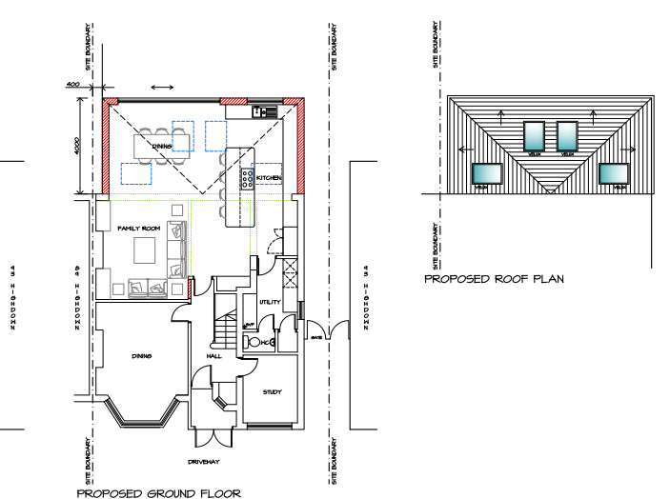

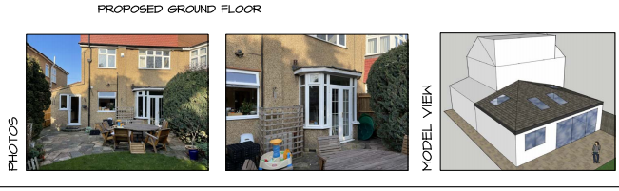

**Recommendation:**

The determination of this application falls within the scope of Officer delegated powers - **YES**

**I therefore recommend the following:**

1. REFUSAL
2. PERMISSION
3. FORWARD TO COMMITTEE
4. RAISE NO OBJECTIONS

~~This application is CIL liable YES* NO~~

~~(*If yes, complete CIL tab in Uniform)~~

~~This application requires a Legal Agreement YES* NO~~

~~(*If yes, complete Development Condition Monitoring in Uniform)~~

~~This application has representations online YES NO~~

~~(which are not on the file)~~

~~This application has representations on file YES NO~~

Case Officer (Initials): AVE Dated: 19/04/2021 SGS 20/4/2021

**I agree the recommendation:** AVE

~~Team Leader/Head of Development Management/Principal Planner~~ Senior Planner

Dated: 19/04/2021

This application has been subject to representations that are contrary to the officer recommendation. The Head of Development Management has considered those representations and concluded that the application can be determined without reference to the Planning Committee in conjunction with existing delegated authority.

Head of Development Management: …………………………………..

Dated: …………………………

|  |
| --- |
| **REASONS:** |
| **CONDITIONS:** |
| **INFORMATIVES:** |
| **UDP POLICIES:** |
| **OTHER POLICIES:** |

The following table will populate as a quick check by running the template once items have been entered into Uniform

**SUMMARY OF CONDITIONS AND INFORMATIVES**

**CONDITIONS**

**INFORMATIVES**