Site: 38 Church Road, Teddington, TW11 8PB
Proposal: Proposed single storey rear / infill extension, loft conversion with rear facing 'L' shaped dormer, front facing roof windows and alterations to side / rear first floor fenestration
Application 23/3223/HOT approved on 07/02/2024. All conditions below refer to this application
Condition 2, U0174636 Materials to match exist'-be app'd, reads
“The external surfaces of the building(s) (including brickwork, roofing, windows, doors and rooflights) and all areas of hard surfacing, where applicable, shall not be constructed other than in materials to match the existing and in accordance with details/samples of which shall be submitted to and approved in writing by the Local Planning Authority.
REASON: To ensure that the proposed development is in keeping with the existing building(s) and does not prejudice the appearance of the locality.”
Condition 3, U0174637 Window obscure glazed-No openable, reads:
“The proposed new first-floor window hereby approved on the side elevation of the house shall at no time be openable or glazed, otherwise than in obscured glass, below a minimum height of 1.7 metres (5'7") above the relevant floor level. REASON: To ensure that the proposed development does not prejudice the amenities of adjoining occupiers.”
Condition 4, U0174641 Refuse Arrangements, reads
None of the extensions hereby approved shall be occupied until arrangements for the storage and disposal of refuse/waste have been made in accordance with details to be submitted to and approved in writing by the Local Planning Authority.
REASON: To safeguard the appearance of the property and the amenities of the area.”
Materials
1 Bricks to external elevations (outlined in green on submitted drawings, denoted as 1)
Reclaimed 68mm London yellow stock imperial bricks supplied by Ammaari Stones (https://ammaaristones.co.uk/product/london-yellow-handmade-imperial-stock-68mm-bricks/) to match existing brickwork
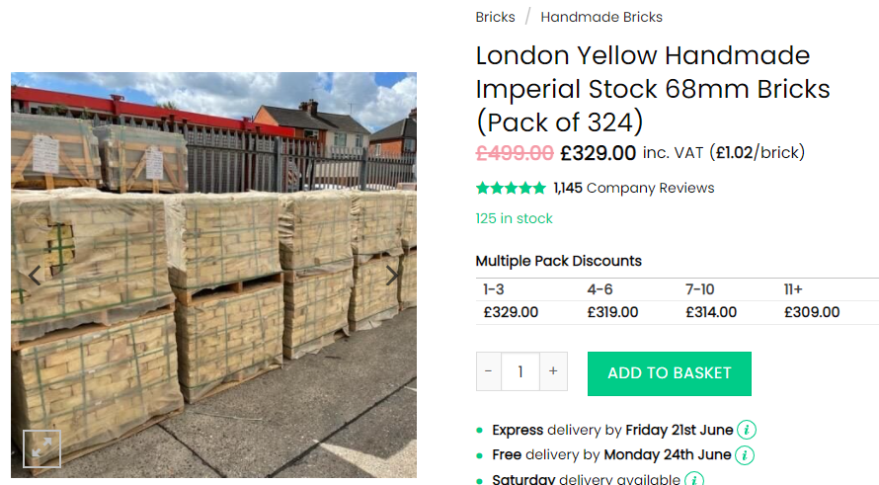
2 Rear bifolding door: denoted on drawing as 2
Door to rear elevation to be aluminium bifold door by LPD Doors Ltd as detailed in attached brochure (LPD_Doors_Aluvu_Brochure.pdf, p10, 10’ 3+0 configuration in anthracite grey)
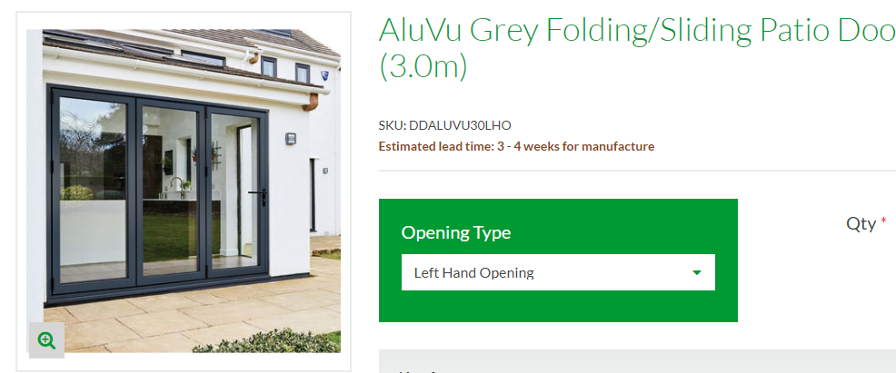

3 2no rooflights to front elevation; 1no rooflight to rear first floor elevation: denoted on drawing as 3
Rooflights on front and rear first floor elevations to be Velux GGL MK06 SD5N2 conservation windows (https://www.roofingsuperstore.co.uk/product/velux-ggl-mk06-sd5n2-conservation-window-for-8mm-slate-78cm-x-118cm.html)
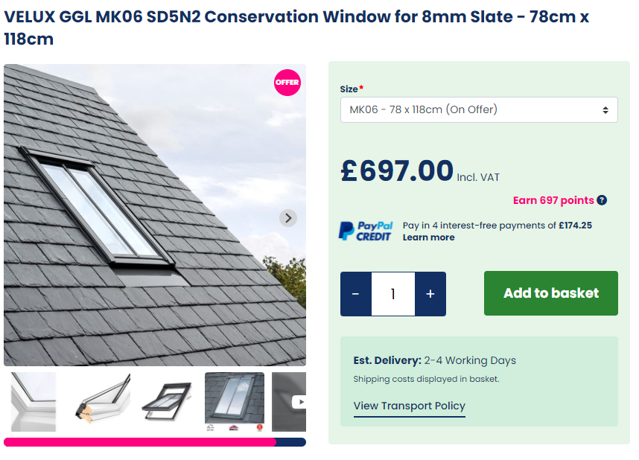

4 4no rooflights on side pitched roof: denoted on drawing as 4
Rooflights on side pitched roof to be Velux GGL MK04 2070 windows, white painted pine (https://www.roofingsuperstore.co.uk/product/velux-ggl-mk04-2070-white-centre-pivot-window-laminated-78cm-x-98cm.html)
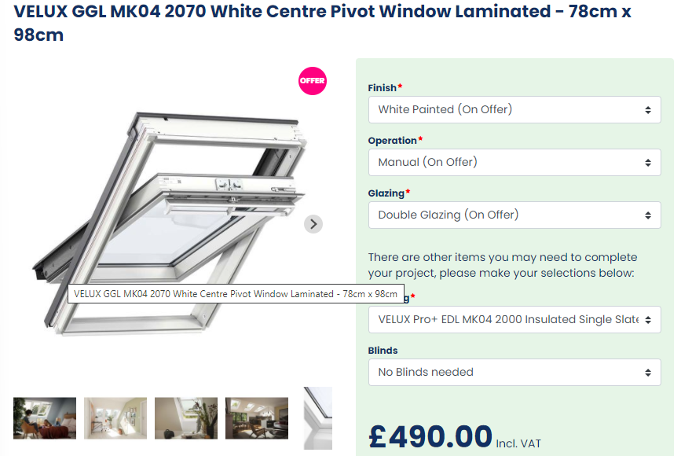

5 2no windows (to bedrooms) on rear elevation, denoted on drawing as 5
Windows to bedrooms and ensuite to be bespoke spiral balanced timber sash windows from Ranebrook windows (example https://www.timberwindowsonline.co.uk/product/spiral-balance-sash-window-1000-1200/)
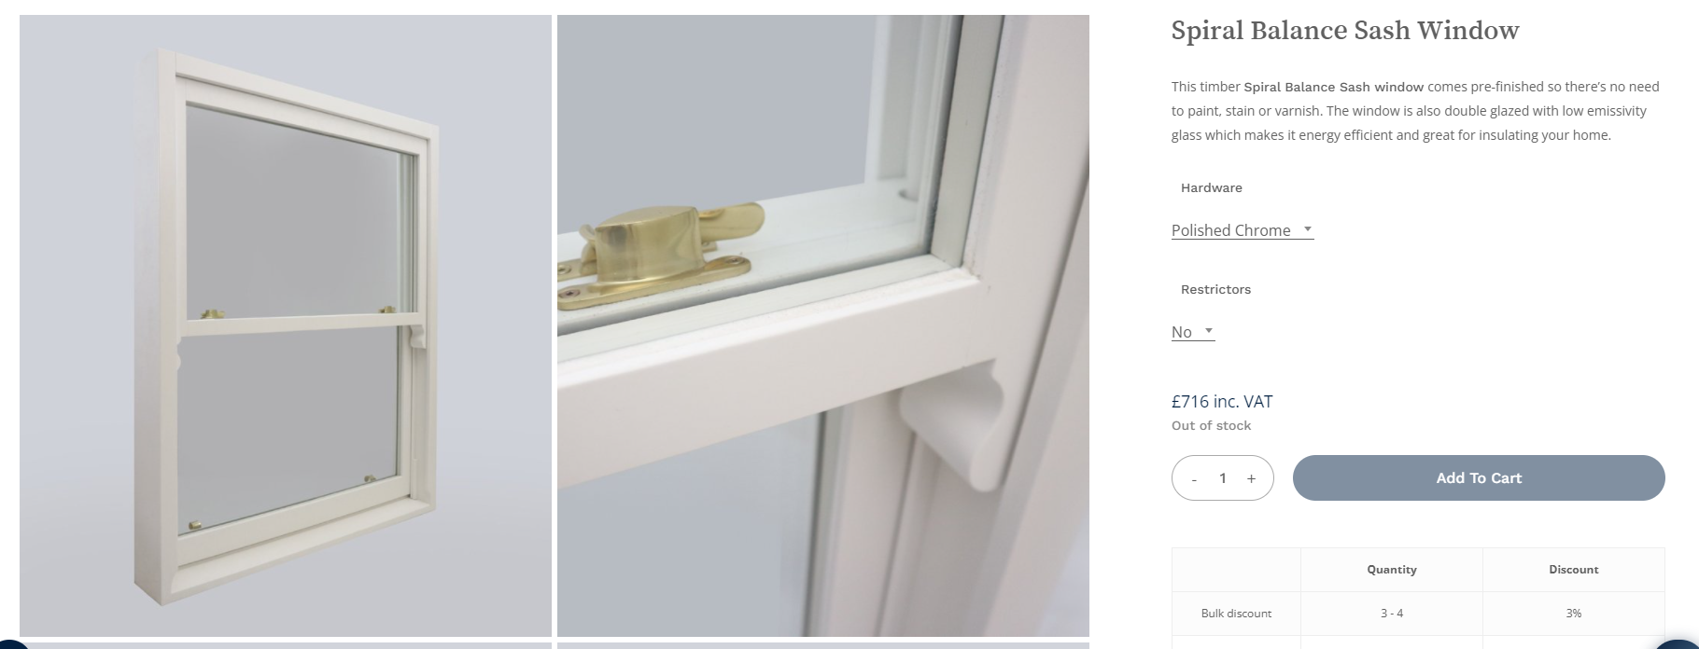
6 1no window to ensuite bathroom on rear elevation and bathroom on first floor side elevation
Windows to ensuite to be bespoke spiral balanced timber sash windows from Ranebrook windows (example https://www.timberwindowsonline.co.uk/product/spiral-balance-sash-window-1000-1200/) with obscured glass. Window to bathroom on first floor to have restricted opening to meet planning condition U0174637
Design as above on point 5

7 superseded – formerly casement windows
8 Roof tiles
Tiles to be Cembrit Westmorland 600x300mm graphite textured slates to match neighbouring property
(https://www.selcobw.com/cembrit-westerland-texured-slate-600-x-300mm-graphite)
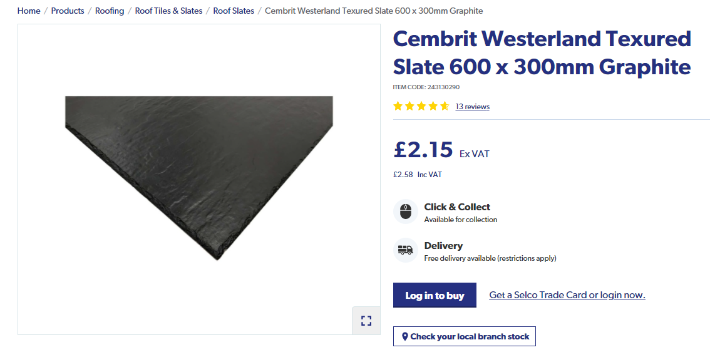

Refuse Arrangements
Pursuant to Condition 4, U0174641: recycling to be stored in council-issued recycling boxes and food caddy; residual refuse to be stored in a dustbin as currently. Boxes, caddy and bin to be stored on front yard as currently and in line with neighbouring properties. Depicted on proposed ground floor plan in blue

